**LAB REPORT**

***Submitted by***

**Aniket Bada Panda [RA2011033010053]**

**Vaibhav Kumar Jha [RA2011033010058]**

**Bedanta Gautom [RA2011033010048]**

***Under the Guidance of***

**Dr.B.Jothi**

***In partial satisfaction of the requirements for the degree of***

## BACHELOR OF TECHNOLOGY

**in**

**COMPUTER SCIENCE ENGINEERING**

**with specialization in software engineering**

**SCHOOL OF COMPUTING**

# **COLLEGE OF ENGINEERING AND TECHNOLOGY**

**SRM INSTITUTE OF SCIENCE AND TECHNOLOGY**

**KATTANKULATHUR - 603203**

**JUNE 2022**

**Index/Table of Contents**

|  |  |  |  |  |
| --- | --- | --- | --- | --- |
| **Sl. no.** | **Date** | **Expt No.** | **Title** | **Remarks** |
| 1 | 16/03/2022 | 1 | Software Project, Business Case, Arrive at a Problem Statement. |  |
| 2 | 23/03/2022 | 2 | Process Methodology and Stakeholder Documentation |  |
| 3 | 30/03/2022 | 3 | System, Functional and Non-Functional Requirements of the Project. |  |
| 4 | 06/04/2022 | 4 | Project Plan based on scope, Calculate Project effort based on resources and Job roles and responsibilities |  |
| 5 | 13/04/2022 | 5 | Work breakdown structure, Timeline chart, Risk identification table |  |
| 6 | 11/05/2022 | 6 | Design a System Architecture, Use Case and Class Diagram |  |
| 7 | 23/05/2022 | 7 | Design a Entity relationship diagram |  |
| 8 | 23/05/2022 | 8 | Develop a Data Flow Diagram (Process-Up to Level 1) |  |
| 9 | 30/05/2022 | 9 | Design a Sequence and Collaboration Diagram |  |
| 10 | 06/06/2022 | 10 | Develop a Testing Framework/User Interface |  |
| 11 | 06/06/2022 | 11 | Test Cases |  |
| 12 | 06/06/2022 | 12 | Manual Test Case Reporting |  |
| 13 | 06/06/2022 | 13 | Provide the details of Architecture Design/ Framework/ Implementation |  |

## Abstract

Today the world totally relays upon the electronic media to its every day adventure. People have no time to be updated through newspaper or watching or listening the news on television or radios. People today need to be updated on daily basis in this competitive world. Most of the people get the information about the world around through the internet which is fast, accessible, and reliable. The WWW (World Wide Web) is huge, widely distributed, global information service centre for Information services: news, advertisements, consumer information, financial management, education, government, e-commerce etc, hyper-link information, access and usage information. "24 Hours News Portal" is a service introduced to meet the above requirement and to make the people updated about the news, views, reviews, breaking news and latest headlines in different fields also the new inventions around the world.



## School of Computing

**SRM IST, Kattankulathur – 603 203 Course Code: 18CSC206J**

### Course Name: Software Engineering and Project Management

|  |  |
| --- | --- |
| **Experiment No** | 1 |
| **Title of Experiment** | To identify the Software Project, Create Business Case, Arrive at a  Problem Statement. |
| **Name of the candidate** | ANIKET BADA PANDA |
| **Team Members** | Aniket Bada Panda (RA2011033010053)  Vaibhav Kumar Jha (RA2011033010058)  Bedanta Gautom (RA2011033010048) |
| **Register Number** | RA2011033010053 |
| **Date of Experiment** | 16/03/2022 |

### Mark Split Up

|  |  |  |  |  |  |
| --- | --- | --- | --- | --- | --- |
| **S.No** |  | **Description** |  | **Maximum Mark** | **Mark Obtained** |
| 1 | Exercise |  |  | 5 |  |
| 2 | Viva |  |  | 5 |  |
|  |  |  | **Total** | **10** |  |

## Staff Signature with date

**Aim**

To frame a project team, analyze and identify a Software project. To create a business case and Arrive at a Problem Statement.

**Team Members:**

|  |  |  |  |
| --- | --- | --- | --- |
| **S. No** | **Register No** | **Name** | **Role** |
| **1** | **RA2011033010053** | **Aniket Bada Panda** | **Lead/Rep** |
| **2** | **RA2011033010058** | **Vaibhav Kumar Jha** | **Member** |
| **3** | **RA2011033010048** | **Bedanta Gautom** | **Member** |

**TITLE**

NewsGlory - Live News Website using News API.

**THE PROJECT**

Live news website allows customers to read up to date news related to many fields like

entertainment, national, international, business, sports etc. without any payment or login

using news API. The objective of this project is to develop a web application for Online

News website that can aware the people and provide the daily news as well as breaking news.

It makes use of various technologies to get required crime-oriented information more quickly,

easily, colourfully and attractively. Anytime, anywhere, anyone can know about the news or

information by internet at low cost. Dynamically provides facility.

**THE HISTORY**

The traditional media rooms all around the world are fast adapting to the new age

technologies. This marks the beginning of news portals by media houses across the globe.

This new media channels give them the opportunity to reach the viewers in a shorter span of

time than their print media counterparts.

**LIMITATIONS**

• Language changing system has not been developed.

• User reply system has not been developed.

**APPROACH**

The design of the website will be created by using HTML, CSS and JavaScript.

We will use News API to get the access of the news data for displaying it in our website.

**BENEFITS**

• News on the Internet can be updated round the clock so that readers can have the most

up-to-date news any time of the day or night.

• Once a news item is put on the internet, it becomes instantly available for use round

the globe without additional variable costs.

• You don’t have to wait for newspaper in morning.

• Any time any news related to different fields will be available.

• Money and time will also save.

• The type of news and the way it is presented can be customized to the needs and

preference of individual readers.

**Result:**

Thus, the project team formed, the project is described, the business case was prepared and the problem statement was arrived.



## School of Computing

**SRM IST, Kattankulathur – 603 203 Course Code: 18CSC206J**

### Course Name: Software Engineering and Project Management

|  |  |
| --- | --- |
| **Experiment No** | 2 |
| **Title of Experiment** | To identify the Process Methodology and Stakeholder Documentation |
| **Name of the candidate** | ANIKET BADA PANDA |
| **Team Members** | Aniket Bada Panda (RA2011033010053)  Vaibhav Kumar Jha (RA2011033010058)  Bedanta Gautom (RA2011033010048) |
| **Register Number** | RA2011033010053 |
| **Date of Experiment** | 23/03/2022 |

### Mark Split Up

|  |  |  |  |  |  |
| --- | --- | --- | --- | --- | --- |
| **S.No** |  | **Description** |  | **Maximum Mark** | **Mark Obtained** |
| 1 | Exercise |  |  | 5 |  |
| 2 | Viva |  |  | 5 |  |
|  |  |  | **Total** | **10** |  |

## Staff Signature with date

**Aim**

To identify the appropriate Process Model for the project and prepare Stakeholder and User Description.

**Team Members:**

|  |  |  |  |
| --- | --- | --- | --- |
| **S. No** | **Register No** | **Name** | **Role** |
| **1** | **RA2011033010053** | **Aniket Bada Panda** | **Lead/Rep** |
| **2** | **RA2011033010058** | **Vaibhav Kumar Jha** | **Member** |
| **3** | **RA2011033010048** | **Bedanta Gautom** | **Member** |

**Project Title: News Website**

**Stakeholder Documentation and their impacts:**

|  |  |  |  |  |
| --- | --- | --- | --- | --- |
| Project Name – NewsGlory(Live news website) | | | | |
| Prepared by – Aniket Bada Panda, Bedanta Gautom, Vaibhav Kumar Jha | | | | |
| Date – 23-03-2022 | | | | |
| **Project**  **Stakeholder** | **Specific**  **Information**  **Needs** | **Project Interests** | **Impact on Project** | **Role** |
| **Types &**  **Frequency of**  **Communication** | **Specific Area of  Interests and**  **Participation** | **Positive,**  **Negative,**  **Influencer,**  **Supporter** | **Decision Maker, Collaborator,**  **Consultant,**  **Information,**  **Recipient** |
| DIRECTOR | Frequent  Communication  Provides guidance  and instructions | Decision Making,  Salary | Supporter,  Positive | Directorial  Management |
| GENERAL  MANAGER | Frequent  Communication  Information on  Business Policies | Directly Engaged,  Profit Growth | Positive Supporter | Decision Maker |
| DEVELOPER | Regular  Communication  Information on  New features | Development of  New Features | Supporter | Information,  Collaborator |

|  |  |  |  |  |
| --- | --- | --- | --- | --- |
| BRAND  MANAGER | Frequent  Communication  Information on  Services and  Policies | Influence the  Overall Revenue | Influencer,  Supporter | Collaborator,  Consultant |
| CUSTOMER | NIL | Provides  Feedback | Supporter | Recipient,  Rating |

**Process model:**

Agile Model

Agile uses an adaptive approach where there is no detailed planning and there is clarity on future

tasks only in respect of what features need to be developed. There is feature driven development

and the team adapts to the changing product requirements dynamically. The product is tested very

frequently, through the release iterations, minimizing the risk of any major failures in future.

**Comparison of methodologies:**

Agile is based on the adaptive software development methods, whereas the traditional SDLC

models like the waterfall model is based on a predictive approach. Predictive teams in the traditional

SDLC models usually work with detailed planning and have a complete forecast of the exact tasks

and features to be delivered in the next few months or during the product life cycle. Predictive

methods entirely depend on the requirement analysis and planning done in the beginning of cycle.

Any changes to be incorporated go through a strict change control management and prioritization.

**Selection of Methodology:**

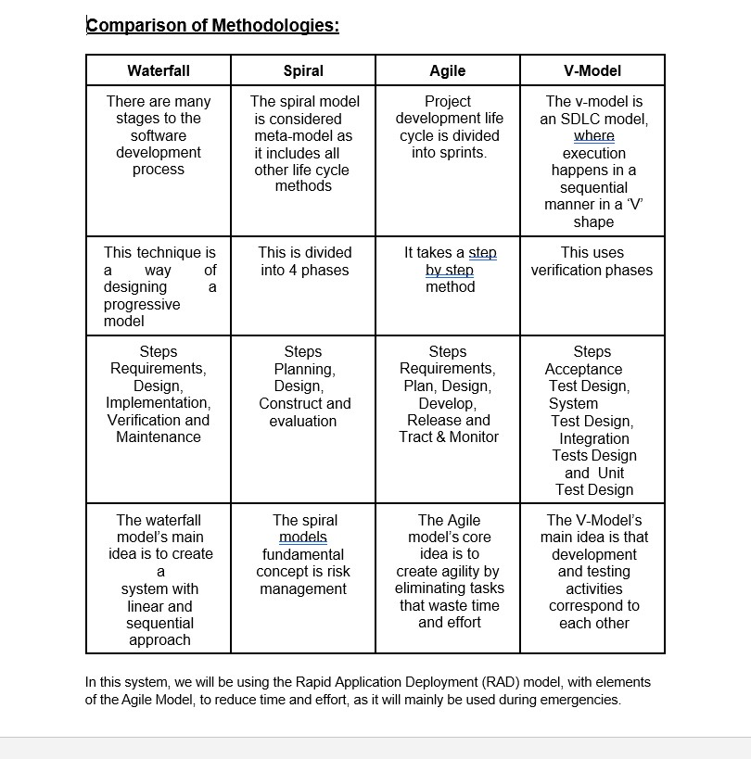

**Result:** Thus the Project Methodology was identified and the stakeholders were described.



## School of Computing

**SRM IST, Kattankulathur – 603 203 Course Code: 18CSC206J**

### Course Name: Software Engineering and Project Management

|  |  |
| --- | --- |
| **Experiment No** | 3 |
| **Title of Experiment** | System, Functional and Non-Functional Requirements of the Project. |
| **Name of the candidate** | ANIKET BADA PANDA |
| **Team Members** | Aniket Bada Panda (RA2011033010053)  Vaibhav Kumar Jha (RA2011033010058)  Bedanta Gautom (RA2011033010048) |
| **Register Number** | RA2011033010053 |
| **Date of Experiment** | 30/03/2022 |

### Mark Split Up

|  |  |  |  |  |  |
| --- | --- | --- | --- | --- | --- |
| **S.No** |  | **Description** |  | **Maximum Mark** | **Mark Obtained** |
| 1 | Exercise |  |  | 5 |  |
| 2 | Viva |  |  | 5 |  |
|  |  |  | **Total** | **10** |  |

## Staff Signature with date

**Aim**

To identify the system, functional and non-functional requirements for the project.

**Team Members:**

|  |  |  |  |
| --- | --- | --- | --- |
| **S. No** | **Register No** | **Name** | **Role** |
| **1** | **RA2011033010053** | **Aniket Bada Panda** | **Lead/Rep** |
| **2** | **RA2011033010058** | **Vaibhav Kumar Jha** | **Member** |
| **3** | **RA2011033010048** | **Bedanta Gautom** | **Member** |

**Project Title: News Website**

**Identify the Requirements:**

**Functional requirements –**

Reading news – The website should have simple interface with possibility to observe many

news with small description in one page. Pushing link/button “read more” to see full

information.

Searching – The website should have text field and button “find” to find anything on the web

page.

Sharing – The website should have tools to share this news in social networks.

**Non functional Requirements -**

Project must be simple to use and light weight. Also, that is important to have safe security

system.

**System Requirements –**

Microsoft Windows Vista/7/8

・Mac OS X 10.5 or higher

・iOS 6 or higher

・Android 2.3 or higher

・Internet Explorer 9 or higher (except for compatibility view setting)

・Safari (latest version)

・Google Chrome (latest version)

**Result:** Thus the requirements were identified and accordingly described.



## School of Computing

**SRM IST, Kattankulathur – 603 203 Course Code: 18CSC206J**

### Course Name: Software Engineering and Project Management

|  |  |
| --- | --- |
| **Experiment No** | 4 |
| **Title of Experiment** | Prepare Project Plan based on scope, Calculate Project effort based on resources and Job roles and responsibilities |
| **Name of the candidate** | ANIKET BADA PANDA |
| **Team Members** | Aniket Bada Panda (RA2011033010053)  Vaibhav Kumar Jha (RA2011033010058)  Bedanta Gautom (RA2011033010048) |
| **Register Number** | RA2011033010053 |
| **Date of Experiment** | 06/04/2022 |

### Mark Split Up

|  |  |  |  |  |  |
| --- | --- | --- | --- | --- | --- |
| **S.No** |  | **Description** |  | **Maximum Mark** | **Mark Obtained** |
| 1 | Exercise |  |  | 5 |  |
| 2 | Viva |  |  | 5 |  |
|  |  |  | **Total** | **10** |  |

## Staff Signature with date

**Aim**

To Prepare Project Plan based on scope, Calculate Project effort based on resources, find Job roles and responsibilities.

**Team Members:**

|  |  |  |  |
| --- | --- | --- | --- |
| **S. No** | **Register No** | **Name** | **Role** |
| **1** | **RA2011033010053** | **Aniket Bada Panda** | **Lead/Rep** |
| **2** | **RA2011033010058** | **Vaibhav Kumar Jha** | **Member** |
| **3** | **RA2011033010048** | **Bedanta Gautom** | **Member** |

**Project Title: News Website**

**Cost Estimation**

**Modules:**

● Login : 100 KLOC

● Home : 70 KLOC

● Sports News : 50 KLOC

● Political News : 70 KLOC

● Entertainment News : 60 KLOC

● Search : 40 KLOC

● Feedback : 50 KLOC

● Contact : 30KLOC

Total : 470 KLOC

**Organic** – A software project is said to be an organic type if the team size

required is adequately small, the problem is well understood and has been

solved in the past and also the team members have a nominal experience

regarding the problem.

**Estimation of Effort: Calculations –**

Basic Model –

E = 2.4*(470)^1.05 = 2.4*639.30 = 1534.32 MM

Time = 2.5*(1534.32)^0.38 = 2.5*16.24 = 40.6 ~ 41 Months

Person required = E/Time = 1534.32/40 = 38.358 ~ 38 persons

**Result:** Thus, job efforts and productivity were successfully calculated, using the COCOMO model.



## School of Computing

**SRM IST, Kattankulathur – 603 203 Course Code: 18CSC206J**

### Course Name: Software Engineering and Project Management

|  |  |
| --- | --- |
| **Experiment No** | 5 |
| **Title of Experiment** | Prepare Work breakdown structure, Timeline chart, Risk identification table. |
| **Name of the candidate** | ANIKET BADA PANDA |
| **Team Members** | Aniket Bada Panda (RA2011033010053)  Vaibhav Kumar Jha (RA2011033010058)  Bedanta Gautom (RA2011033010048) |
| **Register Number** | RA2011033010053 |
| **Date of Experiment** | 13/04/2022 |

### Mark Split Up

|  |  |  |  |  |  |
| --- | --- | --- | --- | --- | --- |
| **S.No** |  | **Description** |  | **Maximum Mark** | **Mark Obtained** |
| 1 | Exercise |  |  | 5 |  |
| 2 | Viva |  |  | 5 |  |
|  |  |  | **Total** | **10** |  |

## Staff Signature with date

**Aim**

To prepare Work breakdown structure, Timeline chart, Risk identification table.

**Team Members:**

|  |  |  |  |
| --- | --- | --- | --- |
| **S. No** | **Register No** | **Name** | **Role** |
| **1** | **RA2011033010053** | **Aniket Bada Panda** | **Lead/Rep** |
| **2** | **RA2011033010058** | **Vaibhav Kumar Jha** | **Member** |
| **3** | **RA2011033010048** | **Bedanta Gautom** | **Member** |

**Project Title: News Website**

**Timeline Chart -**

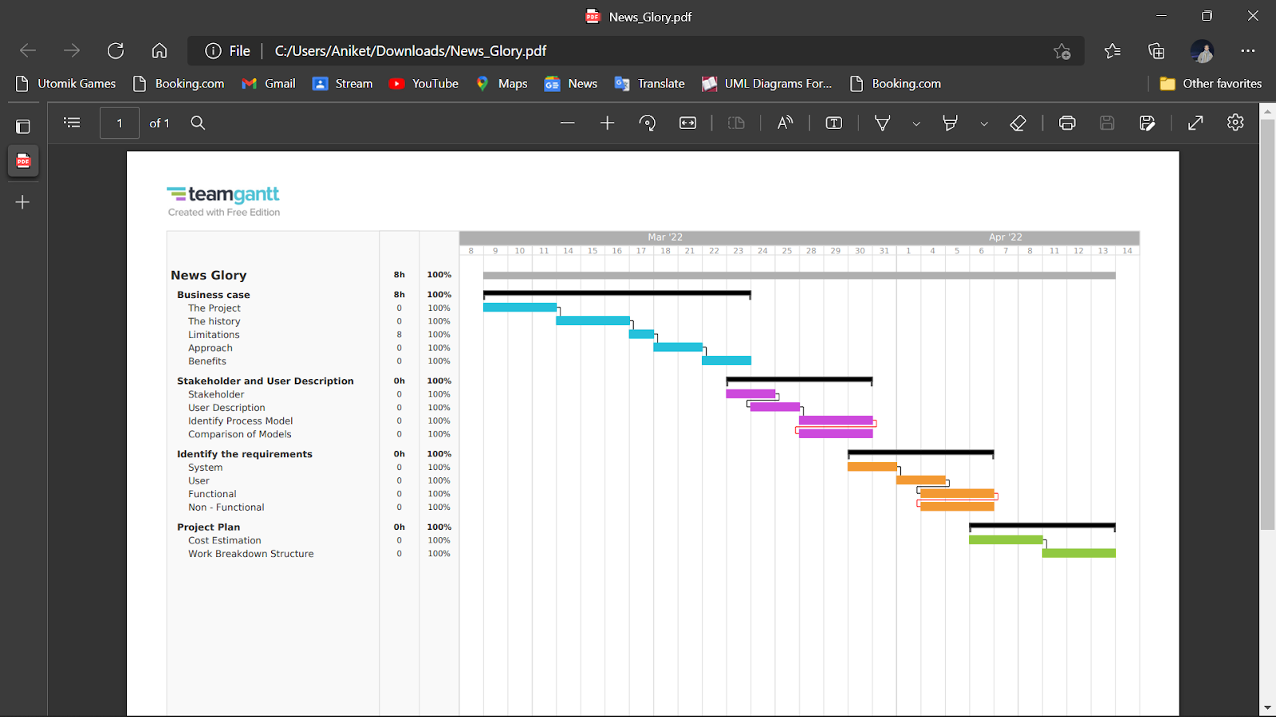

**Work Breakdown Structure -**

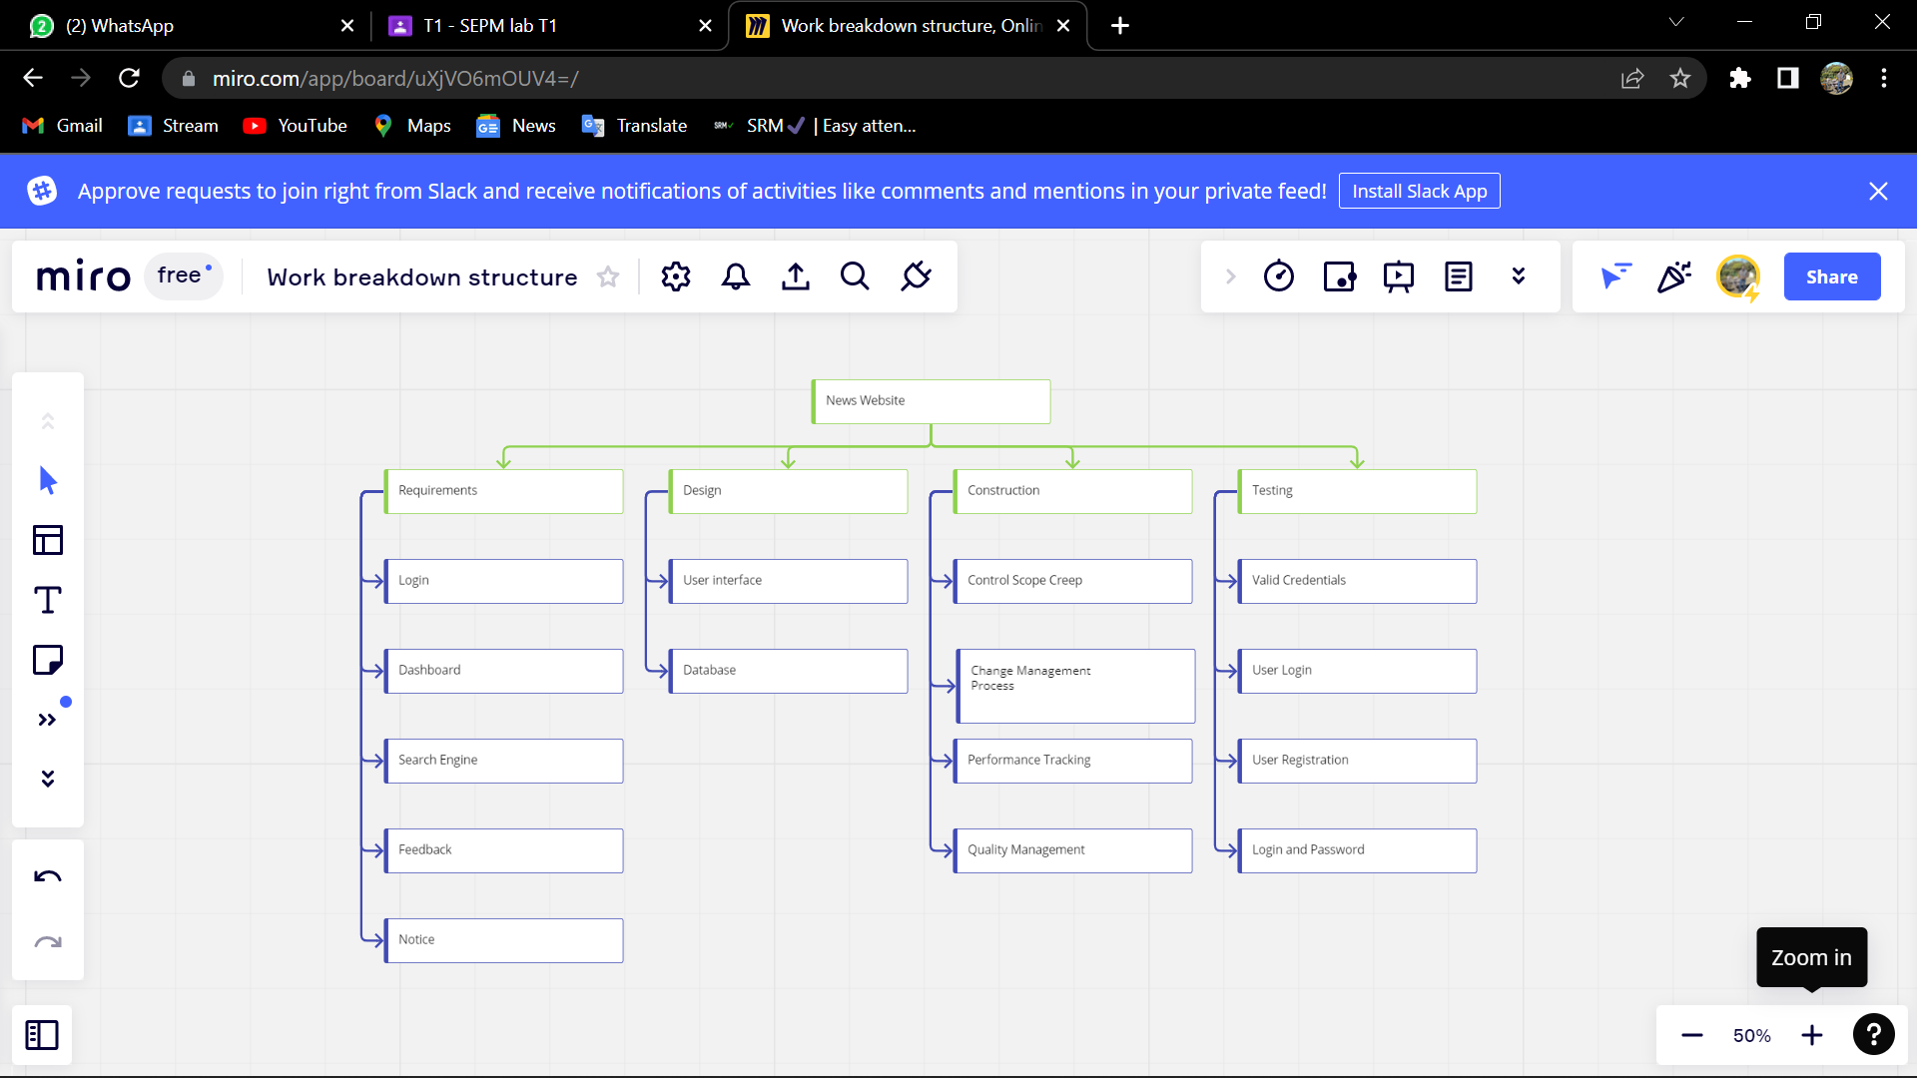

**RISK MANAGEMENT**

Risk from outer world:

• Presence of Similar kind of service providers.

Server End:

• Disk failure of the database system.

• Slow data iteration.

• Improper connection to the internet.

• Hacker’s tent to get the user data.

Solution:

• Using of better disk drive and time to time server maintenance.

• Using of better algorithm for the iteration data.

• Using various trusted Gateway provider.

• Using of captcha to protect it from bot attacks.

**RISK ANALYSIS**

Strengths:

• Online News Website with text-to-speech feature.

• Optimized UI.

• Real time news updates.

Weakness:

• Multiple website with same technology.

Threats:

* Phishing.
* Ransomware.
* SQL injection.
* Cross-site scripting.
* Code injection.
* CEO fraud and impersonation.
* Viruses and worms.
* Spyware.

**Result:** Thus, the Work-Breakdown structure, Timeline diagram and the Risk Table were designed successfully.



## School of Computing

**SRM IST, Kattankulathur – 603 203 Course Code: 18CSC206J**

### Course Name: Software Engineering and Project Management

|  |  |
| --- | --- |
| **Experiment No** | 6 |
| **Title of Experiment** | Design a System Architecture, Use Case and Class Diagram. |
| **Name of the candidate** | ANIKET BADA PANDA |
| **Team Members** | Aniket Bada Panda (RA2011033010053)  Vaibhav Kumar Jha (RA2011033010058)  Bedanta Gautom (RA2011033010048) |
| **Register Number** | RA2011033010053 |
| **Date of Experiment** | 11/05/2022 |

### Mark Split Up

|  |  |  |  |  |  |
| --- | --- | --- | --- | --- | --- |
| **S.No** |  | **Description** |  | **Maximum Mark** | **Mark Obtained** |
| 1 | Exercise |  |  | 5 |  |
| 2 | Viva |  |  | 5 |  |
|  |  |  | **Total** | **10** |  |

## Staff Signature with date

**Aim**

To Design a System Architecture, Use case and Class Diagram.

**Team Members:**

|  |  |  |  |
| --- | --- | --- | --- |
| **S. No** | **Register No** | **Name** | **Role** |
| **1** | **RA2011033010053** | **Aniket Bada Panda** | **Lead/Rep** |
| **2** | **RA2011033010058** | **Vaibhav Kumar Jha** | **Member** |
| **3** | **RA2011033010048** | **Bedanta Gautom** | **Member** |

**Use-case diagram:**

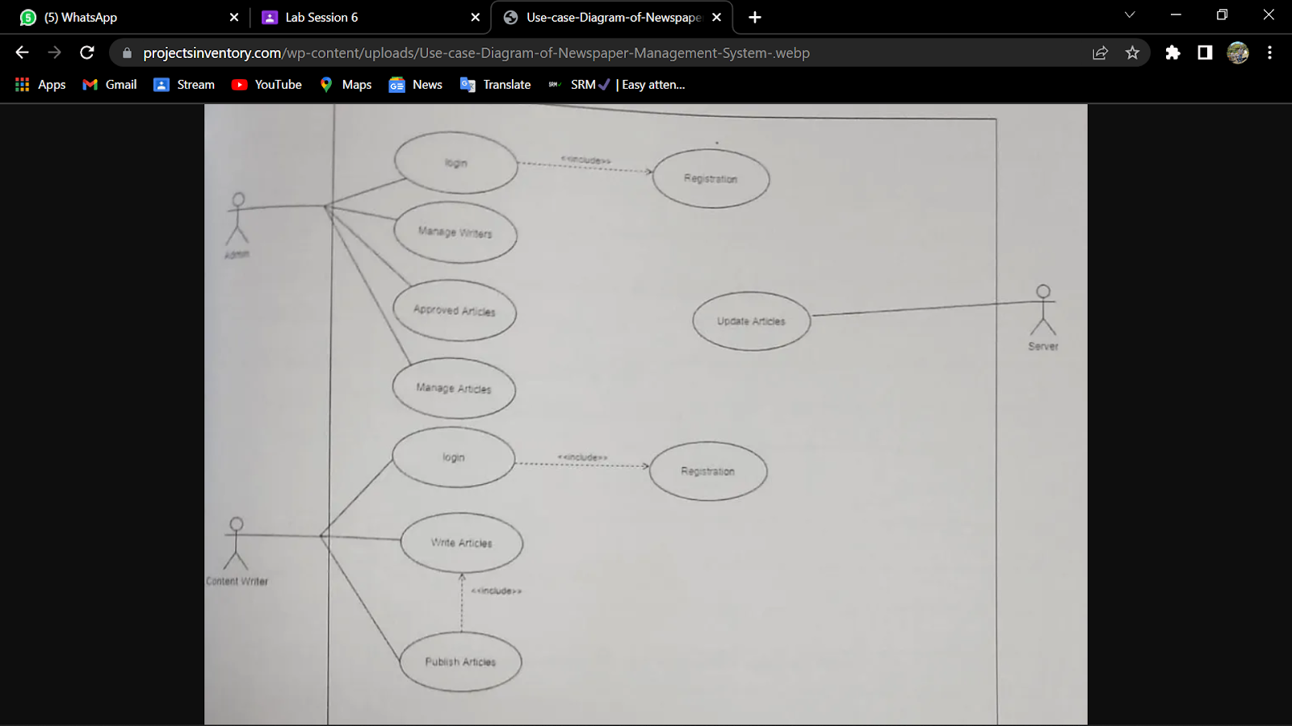

**Class diagram:**

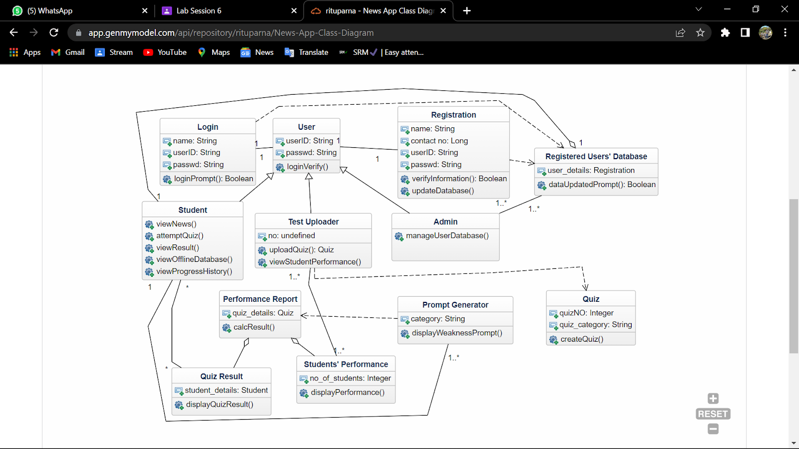

**Architecture diagram:**

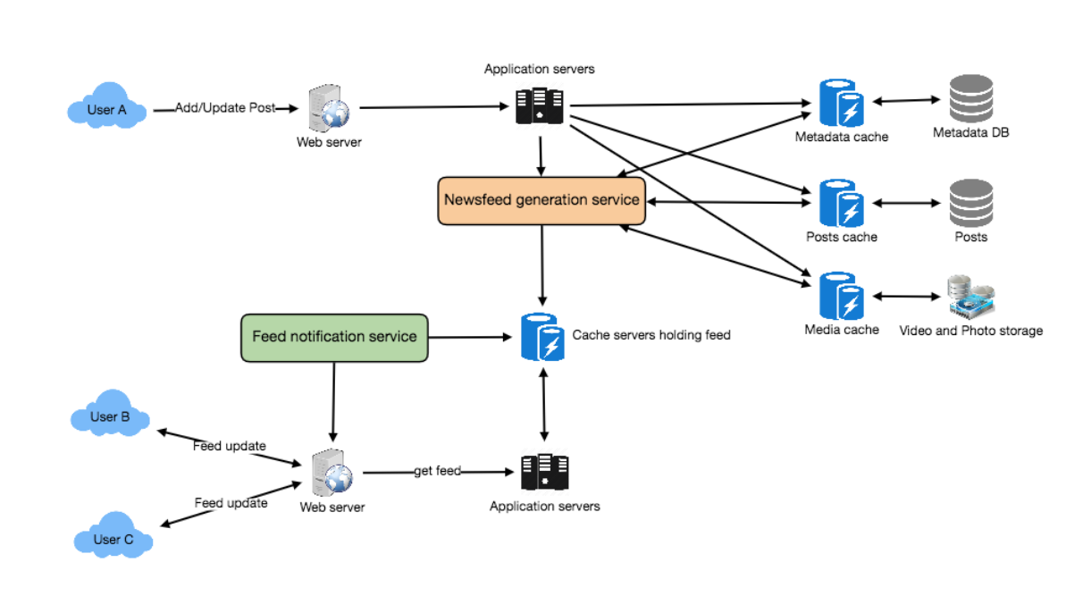

**Result:** The use-case, class and architecture diagrams for the system were designed successfully.



## School of Computing

**SRM IST, Kattankulathur – 603 203 Course Code: 18CSC206J**

### Course Name: Software Engineering and Project Management

|  |  |
| --- | --- |
| **Experiment No** | 7 |
| **Title of Experiment** | Design a Entity relationship diagram |
| **Name of the candidate** | ANIKET BADA PANDA |
| **Team Members** | Aniket Bada Panda (RA2011033010053)  Vaibhav Kumar Jha (RA2011033010058)  Bedanta Gautom (RA2011033010048) |
| **Register Number** | RA2011033010053 |
| **Date of Experiment** | 23/05/2022 |

### Mark Split Up

|  |  |  |  |  |  |
| --- | --- | --- | --- | --- | --- |
| **S.No** |  | **Description** |  | **Maximum Mark** | **Mark Obtained** |
| 1 | Exercise |  |  | 5 |  |
| 2 | Viva |  |  | 5 |  |
|  |  |  | **Total** | **10** |  |

## Staff Signature with date

**Aim**

To create the Entity Relationship Diagram

**Team Members:**

|  |  |  |  |
| --- | --- | --- | --- |
| **S. No** | **Register No** | **Name** | **Role** |
| **1** | **RA2011033010053** | **Aniket Bada Panda** | **Lead/Rep** |
| **2** | **RA2011033010058** | **Vaibhav Kumar Jha** | **Member** |
| **3** | **RA2011033010048** | **Bedanta Gautom** | **Member** |

**What is ER Diagram?**

- ER Diagram stands for Entity Relationship Diagram, also known as ERD is a diagram that displays the relationship of entity sets stored in a database. In other words, ER diagrams help to explain the logical structure of databases. ER diagrams are created based on three basic concepts: entities, attributes and relationships.

- ER Diagrams contain different symbols that use rectangles to represent entities, ovals to define attributes and diamond shapes to represent relationships.

- At first look, an ER diagram looks very similar to the flowchart. However, ER Diagram includes many specialized symbols, and its meanings make this model unique. The purpose of ER Diagram is to represent the entity framework infrastructure.

**What is ER Model?**

- ER Model stands for Entity Relationship Model is a high-level conceptual data model diagram. ER model helps to systematically analyze data requirements to produce a well-designed database.

- ER Model represents real-world entities and the relationships between them. Creating an ER Model in DBMS is considered as a best practice before implementing your database.

- ER Modeling helps you to analyze data requirements systematically to produce a well-designed database. So, it is considered a best practice to complete ER modeling before implementing your database.

**Why use ER Diagrams?**

Here, are prime reasons for using the ER Diagram

- Helps you to define terms related to entity relationship modeling

- Provide a preview of how all your tables should connect, what fields are going to be on each table

- Helps to describe entities, attributes, relationships

- ER diagrams are translatable into relational tables which allows you to build databases quickly

- ER diagrams can be used by database designers as a blueprint for implementing data in specific software applications

- The database designer gains a better understanding of the information to be contained in the database with the help of ERP diagram

- ERD Diagram allows you to communicate with the logical structure of the database to users

**Components of the ER Diagram**

This model is based on three basic concepts: Entities, Attributes, Relationships

**ER Diagram – Notations**

- Rectangles represent entity sets.

- Diamonds represent relationship sets.

- Lines link attributes to entity sets and entity sets to relationship sets.

- Ellipses represent attributes

- Double ellipses represent multivalued attributes.

- Dashed ellipses denote derived attributes.

- Underline indicates primary key attributes

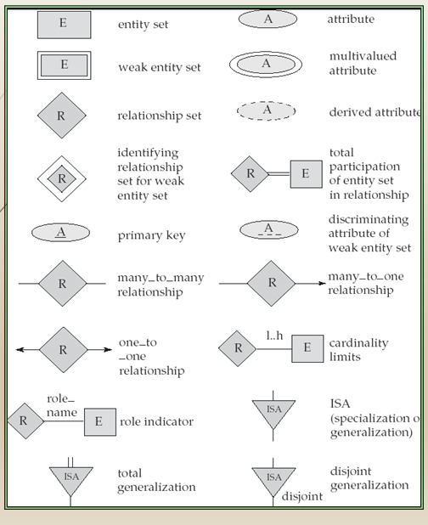

**ER Diagram of News Portal –**

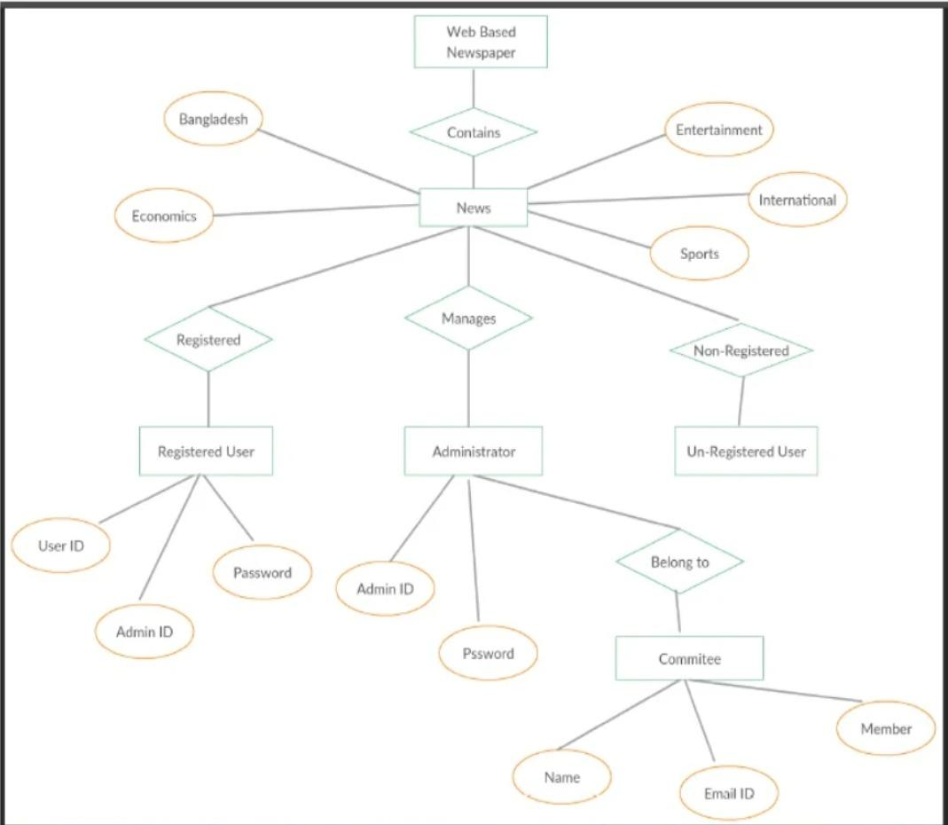

**ADDITIONAL NOTES**

- A database can be modeled as a collection of entities, relationship among entities.

- An entity is an object that exists and is distinguishable from other objects.

Example:  specific person, company, event, plant

- Entities have attributes.

Example: people have names and addresses

- An entity set is a set of entities of the same type that share the same properties.

Example: set of all persons, companies, trees, holidays

- Express the number of entities to which another entity can be associated via a relationship set.

- Most useful in describing binary relationship sets.

- We express cardinality constraints by drawing either a directed line (->), signifying “one,” or an undirected line (—), signifying “many,” between the relationship set and the entity set.

- An entity is represented by a set of attributes, that is descriptive properties possessed by all members of an entity set.

Example: customer = (customer-id, customer-name, customer-street, customer-city)  
 loan = (loan-number, amount)

- Domain – the set of permitted values for each attribute

- Attribute types:

1. Simple and composite attributes.

2. Single-valued and multi-valued attributes

E.g. multivalued attribute: phone-numbers

3. Derived attributes-Can be computed from other attributes

E.g.  age, given date of birth

**Cardinality**

- For a binary relationship set the mapping cardinality must be one of the following types:

1. One to one

A customer is associated with at most one loan via the relationship borrower. A loan is associated with at most one customer via borrower

2. One to many

A loan is associated with at most one customer via borrower, a customer is associated with several (including 0) loans via borrower

3. Many to one

A loan is associated with several (including 0) customers via borrower, a customer is associated with at most one loan via borrower

4. Many to many

A loan is associated with several (including 0) customers via borrower, a customer is associated with several loans (including 0) via borrower

**Weak Entity Set**

- An entity set that does not have a primary key is referred to as a weak entity set and represented by double outlined box in E-R diagram.

Example : Consider the entity set payment which got three attributes : payment_number, payment_date and payment_amount. Payment numbers are sequential starting from 1 generally separately for each loan. Although each payment entity is distinct, payments for different loans may share the same payment number. Thus this entity set does not have a primary key.

**Discriminator**

- The discriminator (or partial key) of a weak entity set is the set of attributes that distinguishes among all the  entities of a weak entity set

Example: discriminator of weak entity set payment is the attribute payment_number  since for each loan a payment number uniquely identifies one single payment for that loan.

**Specialization-Generalization-ISA**

- E-R model provides means of representing these distinctive entity groupings

- Process of designating subgroupings within an entity set is called specialization depicted by triangle component labelled ISA (“is a”)

- Bottom up design process in which multiple entity sets are synthesized into higher level entity set - Generalization

- ISA relationship may also be referred to as superclass-subclass relationship

- Higher and lower level entity sets are designated by the terms superclass and subclass.

- Specialization and generalization are simple inversions of each other; they are represented in an E-R diagram in the same way.

**Total & Partial Participation**

- Total participation (indicated by double line):  every entity in the entity set participates in at least one relationship in the relationship set

E.g. participation of loan in borrower is total, every loan must have a customer associated to it via borrower

- Partial participation:  some entities may not participate in any relationship in the relationship set

Example: participation of customer in borrower is partial

**Cardinality limits**

- Cardinality limits can also express participation constraints

- Minimum and maximum cardinality is expressed as l..h where l is the minimum and h is the maximum cardinality

- Minimum  value of 1 indicates total participation of entity set in relationship set

- Maximum value of 1 indicates entity participates in atmost one relationship set.

- Maximum value of * indicates no limit

**Role indicator**

- Entity sets of a relationship need not be distinct

- The labels “manager” and “worker” are called roles; they specify how employee entities interact via the works-for relationship set.

- Roles are indicated in E-R diagrams by labeling the lines that connect diamonds to rectangles.

- Role labels are optional, and are used to clarify semantics of the relationship

**Disjoint Generalization**

- Disjointness constraint requires that an entity belong to more than one lower level entity set.

Example: account entity can satisfy only one condition for account_type attribute ; entity can either be savings or chequing account but not both.

**Result:** The ER Diagram for the system was drawn successfully.



## School of Computing

**SRM IST, Kattankulathur – 603 203 Course Code: 18CSC206J**

### Course Name: Software Engineering and Project Management

|  |  |
| --- | --- |
| **Experiment No** | 8 |
| **Title of Experiment** | Develop a Data Flow Diagram (Process-Up to Level 1) |
| **Name of the candidate** | ANIKET BADA PANDA |
| **Team Members** | Aniket Bada Panda (RA2011033010053)  Vaibhav Kumar Jha (RA2011033010058)  Bedanta Gautom (RA2011033010048) |
| **Register Number** | RA2011033010053 |
| **Date of Experiment** | 23/05/2022 |

### Mark Split Up

|  |  |  |  |  |  |
| --- | --- | --- | --- | --- | --- |
| **S.No** |  | **Description** |  | **Maximum Mark** | **Mark Obtained** |
| 1 | Exercise |  |  | 5 |  |
| 2 | Viva |  |  | 5 |  |
|  |  |  | **Total** | **10** |  |

## Staff Signature with date

**Aim**

To develop the data flow diagram up to level 1 for Diaspora Evacuation System.

**Team Members:**

|  |  |  |  |
| --- | --- | --- | --- |
| **S. No** | **Register No** | **Name** | **Role** |
| **1** | **RA2011033010053** | **Aniket Bada Panda** | **Lead/Rep** |
| **2** | **RA2011033010058** | **Vaibhav Kumar Jha** | **Member** |
| **3** | **RA2011033010048** | **Bedanta Gautom** | **Member** |

**Data Flow Diagram**

The DFD takes an input-process-output view of a system. That is, data objects flow into the software, are transformed by processing elements, and resultant data objects flow out of the software. Data objects are represented by labeled arrows, and transformations are represented by circles (also called bubbles). The DFD is presented in a hierarchical fashion. That is, the first data flow model (sometimes called a level 0 DFD or context diagram) represents the system as a whole. Subsequent data flow diagrams refine the context diagram, providing increasing detail with each subsequent level.

The data flow diagram enables you to develop models of the information domain and functional domain. As the DFD is refined into greater levels of detail, you perform an implicit functional decomposition of the system. At the same time, the DFD refinement results in a corresponding refinement of data as it moves through the processes that embody the application.

A few simple guidelines can aid immeasurably during the derivation of a data flow diagram:

(1) Level 0 data flow diagram should depict the software/system as a

single bubble;

(2) Primary input and output should be carefully noted;

(3) Refinement should begin by isolating candidate processes, data objects, and data stores to be represented at the next level;

(4) All arrows and bubbles should be labeled with meaningful names;

(5) Information flow continuity must be maintained from level to level and

(6) One bubble at a time should be refined. There is a natural tendency to overcomplicate the data flow diagram. This occurs when you attempt to show too much detail too early or represent procedural aspects of the software in lieu of information flow.

**Data Flow Diagram –**

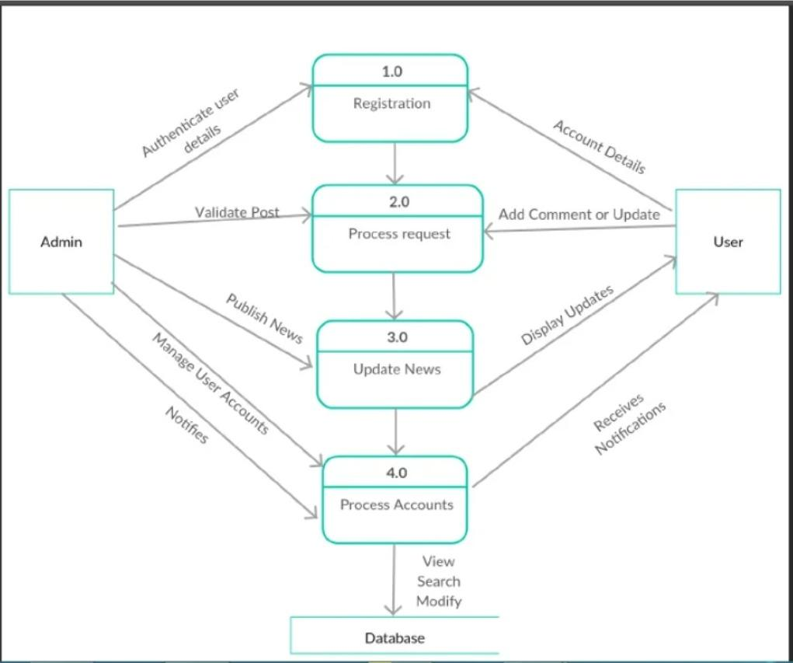

**Result**: Thus, the data flow diagrams have been created



## School of Computing

**SRM IST, Kattankulathur – 603 203 Course Code: 18CSC206J**

### Course Name: Software Engineering and Project Management

|  |  |
| --- | --- |
| **Experiment No** | 9 |
| **Title of Experiment** | Design a Sequence and Collaboration Diagram |
| **Name of the candidate** | ANIKET BADA PANDA |
| **Team Members** | Aniket Bada Panda (RA2011033010053)  Vaibhav Kumar Jha (RA2011033010058)  Bedanta Gautom (RA2011033010048) |
| **Register Number** | RA2011033010053 |
| **Date of Experiment** | 30/05/2022 |

### Mark Split Up

|  |  |  |  |  |  |
| --- | --- | --- | --- | --- | --- |
| **S.No** |  | **Description** |  | **Maximum Mark** | **Mark Obtained** |
| 1 | Exercise |  |  | 5 |  |
| 2 | Viva |  |  | 5 |  |
|  |  |  | **Total** | **10** |  |

## Staff Signature with date

**Aim**

To develop the Sequence and Collaboration Diagram for News Website.

**Team Members:**

|  |  |  |  |
| --- | --- | --- | --- |
| **S. No** | **Register No** | **Name** | **Role** |
| **1** | **RA2011033010053** | **Aniket Bada Panda** | **Lead/Rep** |
| **2** | **RA2011033010058** | **Vaibhav Kumar Jha** | **Member** |
| **3** | **RA2011033010048** | **Bedanta Gautom** | **Member** |

**Sequence Diagram:**

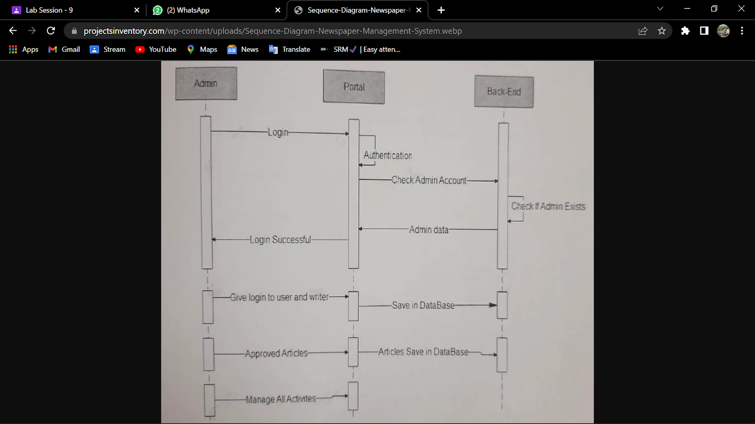

Collaboration Diagram:

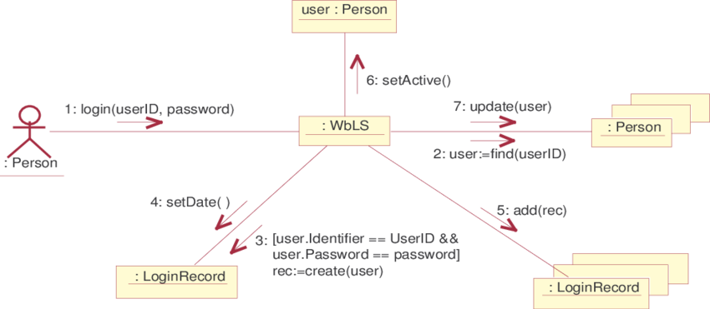

**Result:** Thus, the sequence and collaboration diagrams were created.



## School of Computing

**SRM IST, Kattankulathur – 603 203 Course Code: 18CSC206J**

### Course Name: Software Engineering and Project Management

|  |  |
| --- | --- |
| **Experiment No** | 10 |
| **Title of Experiment** | Develop a Testing Framework/User Interface |
| **Name of the candidate** | ANIKET BADA PANDA |
| **Team Members** | Aniket Bada Panda (RA2011033010053)  Vaibhav Kumar Jha (RA2011033010058)  Bedanta Gautom (RA2011033010048) |
| **Register Number** | RA2011033010053 |
| **Date of Experiment** | 06/06/2022 |

### Mark Split Up

|  |  |  |  |  |  |
| --- | --- | --- | --- | --- | --- |
| **S.No** |  | **Description** |  | **Maximum Mark** | **Mark Obtained** |
| 1 | Exercise |  |  | 5 |  |
| 2 | Viva |  |  | 5 |  |
|  |  |  | **Total** | **10** |  |

## Staff Signature with date

**Aim**

To develop the testing framework and/or user interface **(login system)** framework for News Website.

**Team Members:**

|  |  |  |  |
| --- | --- | --- | --- |
| **S. No** | **Register No** | **Name** | **Role** |
| **1** | **RA2011033010053** | **Aniket Bada Panda** | **Lead/Rep** |
| **2** | **RA2011033010058** | **Vaibhav Kumar Jha** | **Member** |
| **3** | **RA2011033010048** | **Bedanta Gautom** | **Member** |

**UI Framework:**

Objective –

We have to design and build an web application of news website. As the time is progressing we are in need of being aware about the world by news. It is very important for our daily life.

Approach –

I. Unit testing – Here we are testing each module and if error comes it will

be solved at unit level.

II. Integration testing – Here we are combining different modules and

testing their compatibility.

III. System testing – Here we are going to test its compatibility with different

systems.

IV. Acceptance testing – Here we are going to test it with whether it will be

accepted by the user or whether it fulfills the users requirement or not.

**1)Login Interface:**

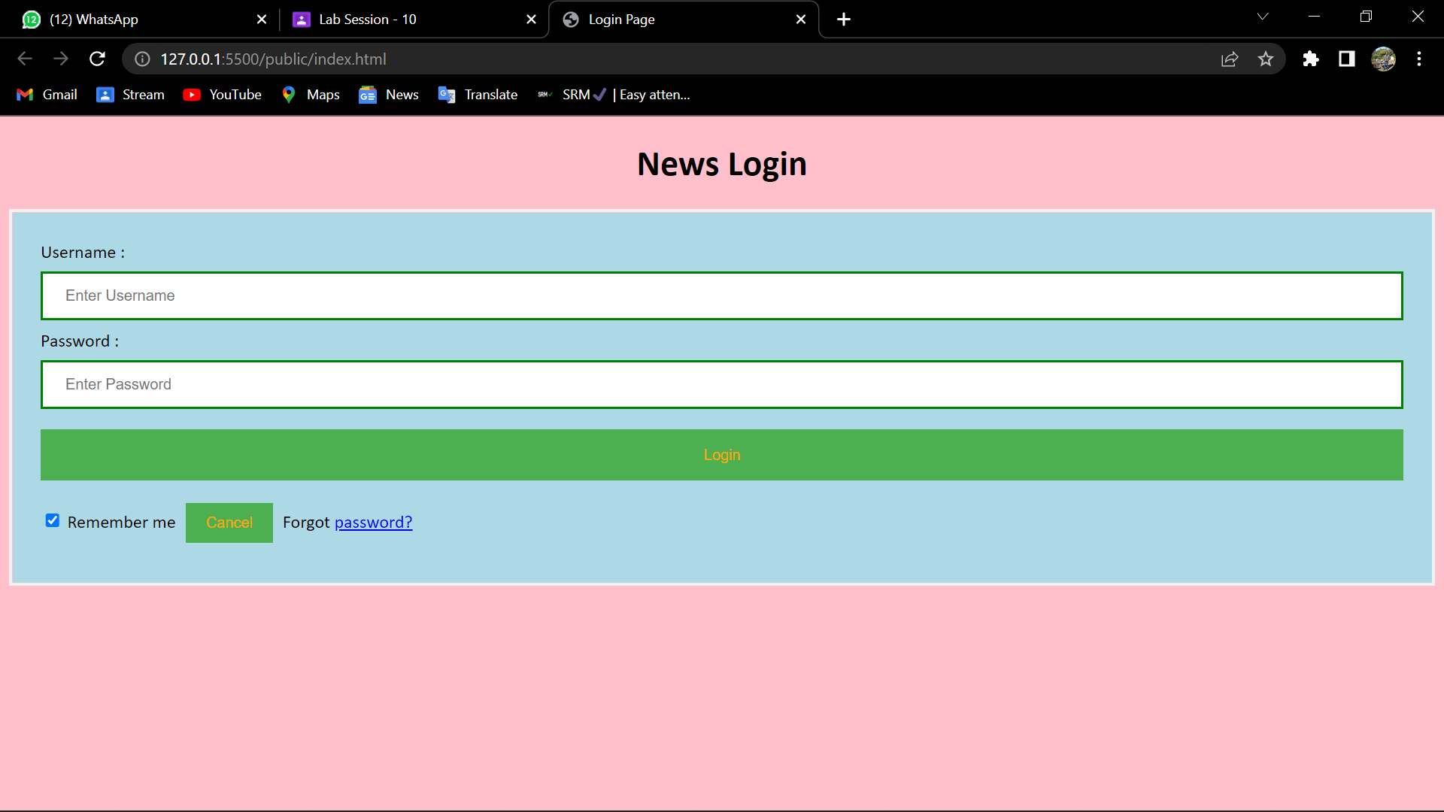

**2) UI after login:**

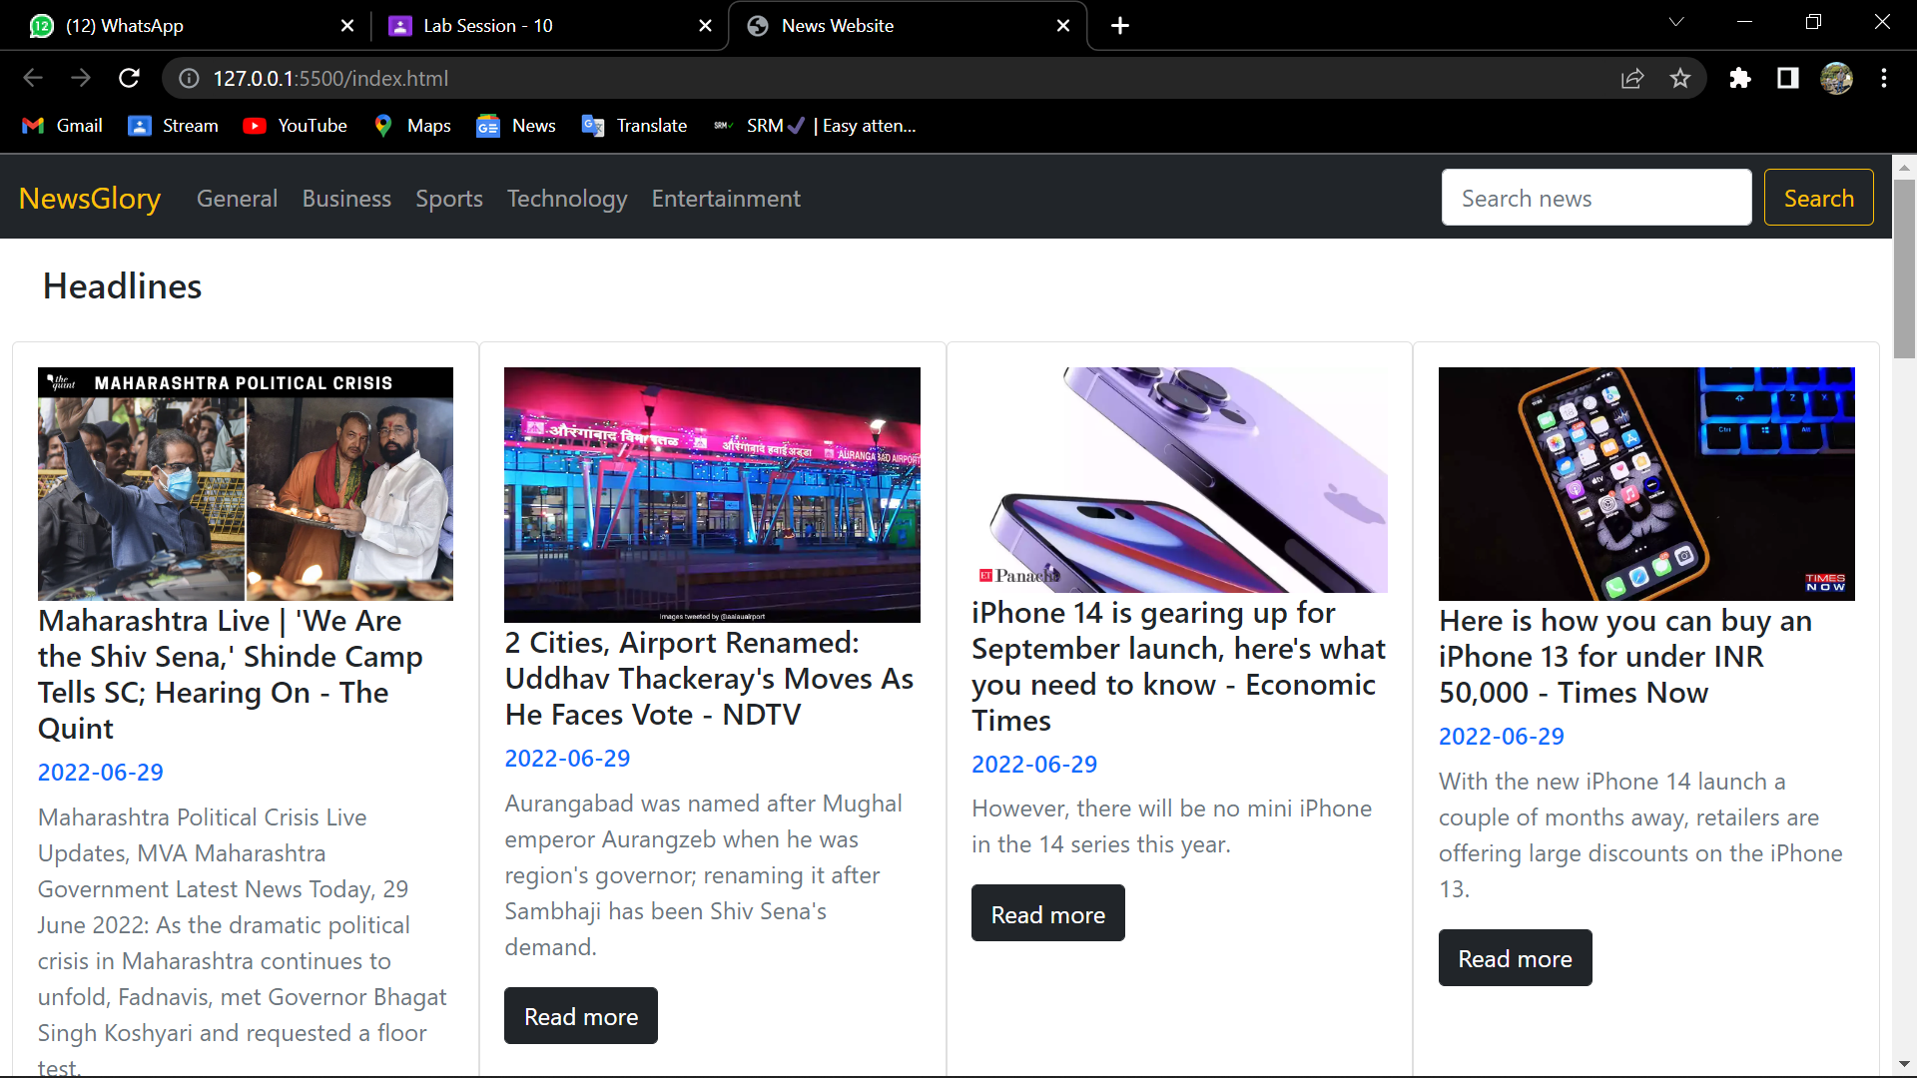

**Result:** Thus, the user interface framework has been created for the DES(Diaspora Evacuation System).



## School of Computing

**SRM IST, Kattankulathur – 603 203 Course Code: 18CSC206J**

### Course Name: Software Engineering and Project Management

|  |  |
| --- | --- |
| **Experiment No** | 11 |
| **Title of Experiment** | Test Cases |
| **Name of the candidate** | ANIKET BADA PANDA |
| **Team Members** | Aniket Bada Panda (RA2011033010053)  Vaibhav Kumar Jha (RA2011033010058)  Bedanta Gautom (RA2011033010048) |
| **Register Number** | RA2011033010053 |
| **Date of Experiment** | 06/06/2022 |

### Mark Split Up

|  |  |  |  |  |  |
| --- | --- | --- | --- | --- | --- |
| **S.No** |  | **Description** |  | **Maximum Mark** | **Mark Obtained** |
| 1 | Exercise |  |  | 5 |  |
| 2 | Viva |  |  | 5 |  |
|  |  |  | **Total** | **10** |  |

## Staff Signature with date

**Aim**

To develop the test cases manual for News Website.

**Team Members:**

|  |  |  |  |
| --- | --- | --- | --- |
| **S. No** | **Register No** | **Name** | **Role** |
| **1** | **RA2011033010053** | **Aniket Bada Panda** | **Lead/Rep** |
| **2** | **RA2011033010058** | **Vaibhav Kumar Jha** | **Member** |
| **3** | **RA2011033010048** | **Bedanta Gautom** | **Member** |

**Test Cases:**

|  |  |  |  |  |  |  |  |
| --- | --- | --- | --- | --- | --- | --- | --- |
| **Test ID (#)** | **Test Scenario** | **Test Case** | **Execution Steps** | **Expected Outcome** | **Actual Outcome** | **Status** | **Remarks** |
| 1 | Verify User Registration from India | Accept Valid India Mobile Number on the Page#1 | 1. User clicks on User Registration link 2. Enter the mobile Number on the text box 3. Click Register button | User should be taken to the next page for entering more user details |  | Pass | success |
|  | Verify User Registration from India | Don’t Accept Non IndianMobile Number on the Page#1 |  | User should type the mobile number again with correct country code. |  | Failure |  |
| 2 | Log in with the valid credentials i.e. correct username and password | Correct username and password#2 | 1. User clicks on the login page link. 2. User enters the email id/phone no. and password in the desired field. 3. Click login button. | User should be taken to the news feed page. |  | Pass | success |
|  |  | Incorrect username and password#2 |  | User should type the correct username and password for login. |  | Failure |  |
| 3 | Check user should register by filling all the required fields in Registration page. | Filled all the required fields.#3 | 1. Enter valid values in the required fields.  2. Click the create account button. | 1. Users should be registered successfully.  2. A successful registration message should show.  3. Mail should send to the user. |  | Pass | success |
|  |  | Did not fill all the required fields.#3 |  | User should fill all the required fields. |  | Failure |  |

**Result**: Thus, the test case manual has been created for the News Website.



## School of Computing

**SRM IST, Kattankulathur – 603 203 Course Code: 18CSC206J**

### Course Name: Software Engineering and Project Management

|  |  |
| --- | --- |
| **Experiment No** | 12 |
| **Title of Experiment** | Manual Test Case Reporting |
| **Name of the candidate** | ANIKET BADA PANDA |
| **Team Members** | Aniket Bada Panda (RA2011033010053)  Vaibhav Kumar Jha (RA2011033010058)  Bedanta Gautom (RA2011033010048) |
| **Register Number** | RA2011033010053 |
| **Date of Experiment** | 06/06/2022 |

### Mark Split Up

|  |  |  |  |  |  |
| --- | --- | --- | --- | --- | --- |
| **S.No** |  | **Description** |  | **Maximum Mark** | **Mark Obtained** |
| 1 | Exercise |  |  | 5 |  |
| 2 | Viva |  |  | 5 |  |
|  |  |  | **Total** | **10** |  |

## Staff Signature with date

**Aim**

To prepare the manual test case report for News Website.

**Team Members:**

|  |  |  |  |
| --- | --- | --- | --- |
| **S. No** | **Register No** | **Name** | **Role** |
| **1** | **RA2011033010053** | **Aniket Bada Panda** | **Lead/Rep** |
| **2** | **RA2011033010058** | **Vaibhav Kumar Jha** | **Member** |
| **3** | **RA2011033010048** | **Bedanta Gautom** | **Member** |

The percentage of success rate and failure rate has been calculated using the following equations: Success:

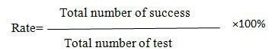



The performance is related to success rate and failure rate. If the success is high then the performance of the system is good. Success rate and Failure rate are contradiction of each other. So when success rate is high then failure rate is low. In the two terms the performance of the system is depended.

**Result:** Thus, the test case report has been created for the News Website.



## School of Computing

**SRM IST, Kattankulathur – 603 203 Course Code: 18CSC206J**

### Course Name: Software Engineering and Project Management

|  |  |
| --- | --- |
| **Experiment No** | 13 |
| **Title of Experiment** | Provide the details of Architecture Design/Framework/Implementation |
| **Name of the candidate** | ANIKET BADA PANDA |
| **Team Members** | Aniket Bada Panda (RA2011033010053)  Vaibhav Kumar Jha (RA2011033010058)  Bedanta Gautom (RA2011033010048) |
| **Register Number** | RA2011033010053 |
| **Date of Experiment** | 06/06/2022 |

### Mark Split Up

|  |  |  |  |  |  |
| --- | --- | --- | --- | --- | --- |
| **S.No** |  | **Description** |  | **Maximum Mark** | **Mark Obtained** |
| 1 | Exercise |  |  | 5 |  |
| 2 | Viva |  |  | 5 |  |
|  |  |  | **Total** | **10** |  |

## Staff Signature with date

**Aim**

To provide the details of architectural design/framework/implementation

**Team Members:**

|  |  |  |  |
| --- | --- | --- | --- |
| **S. No** | **Register No** | **Name** | **Role** |
| **1** | **RA2011033010053** | **Aniket Bada Panda** | **Lead/Rep** |
| **2** | **RA2011033010058** | **Vaibhav Kumar Jha** | **Member** |
| **3** | **RA2011033010048** | **Bedanta Gautom** | **Member** |

**Code:**

**HTML -**

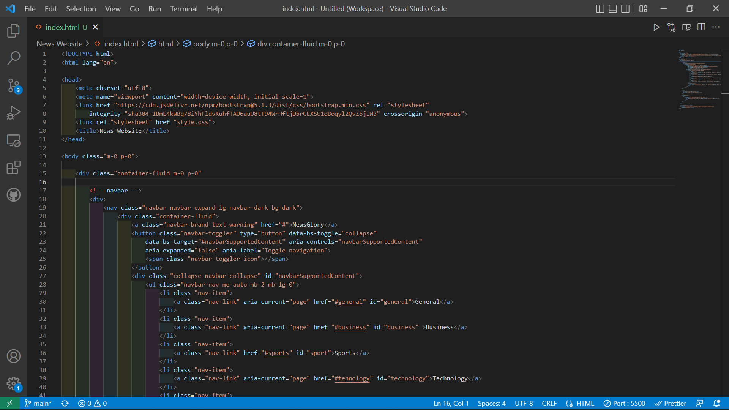

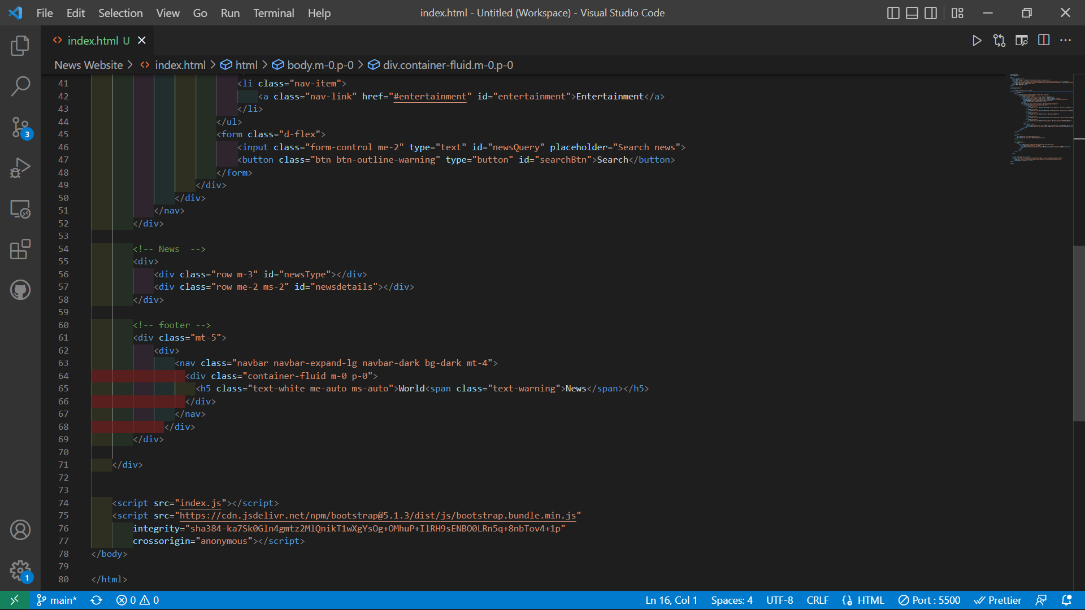

**JavaScript -**

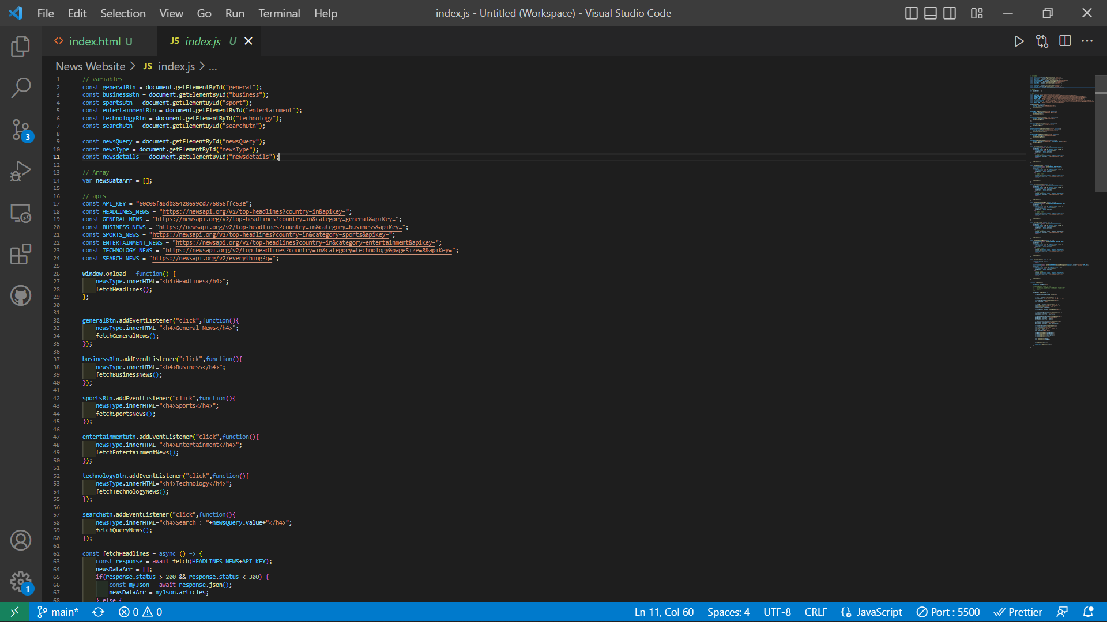

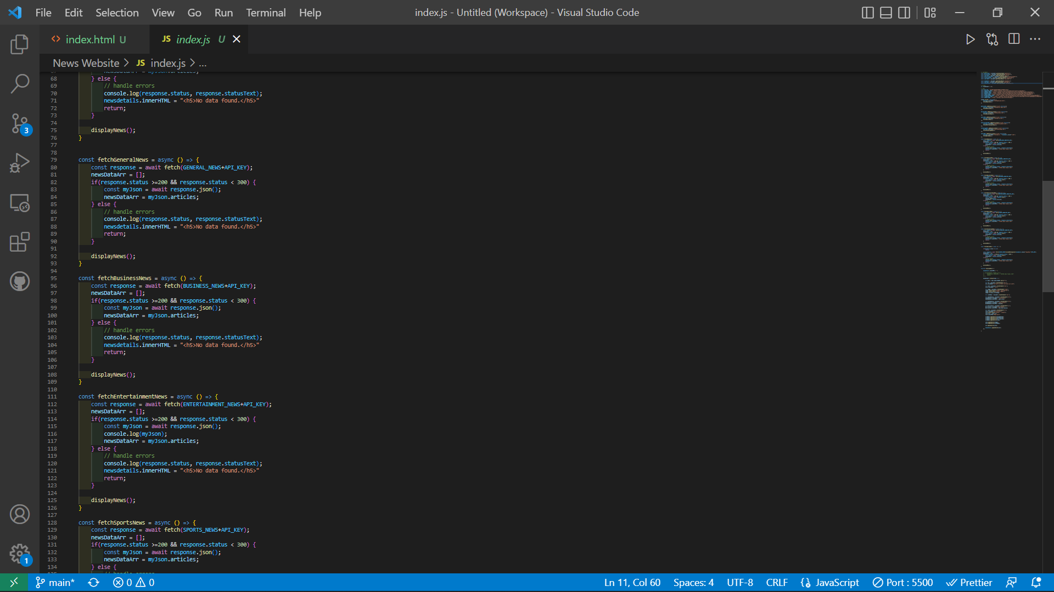

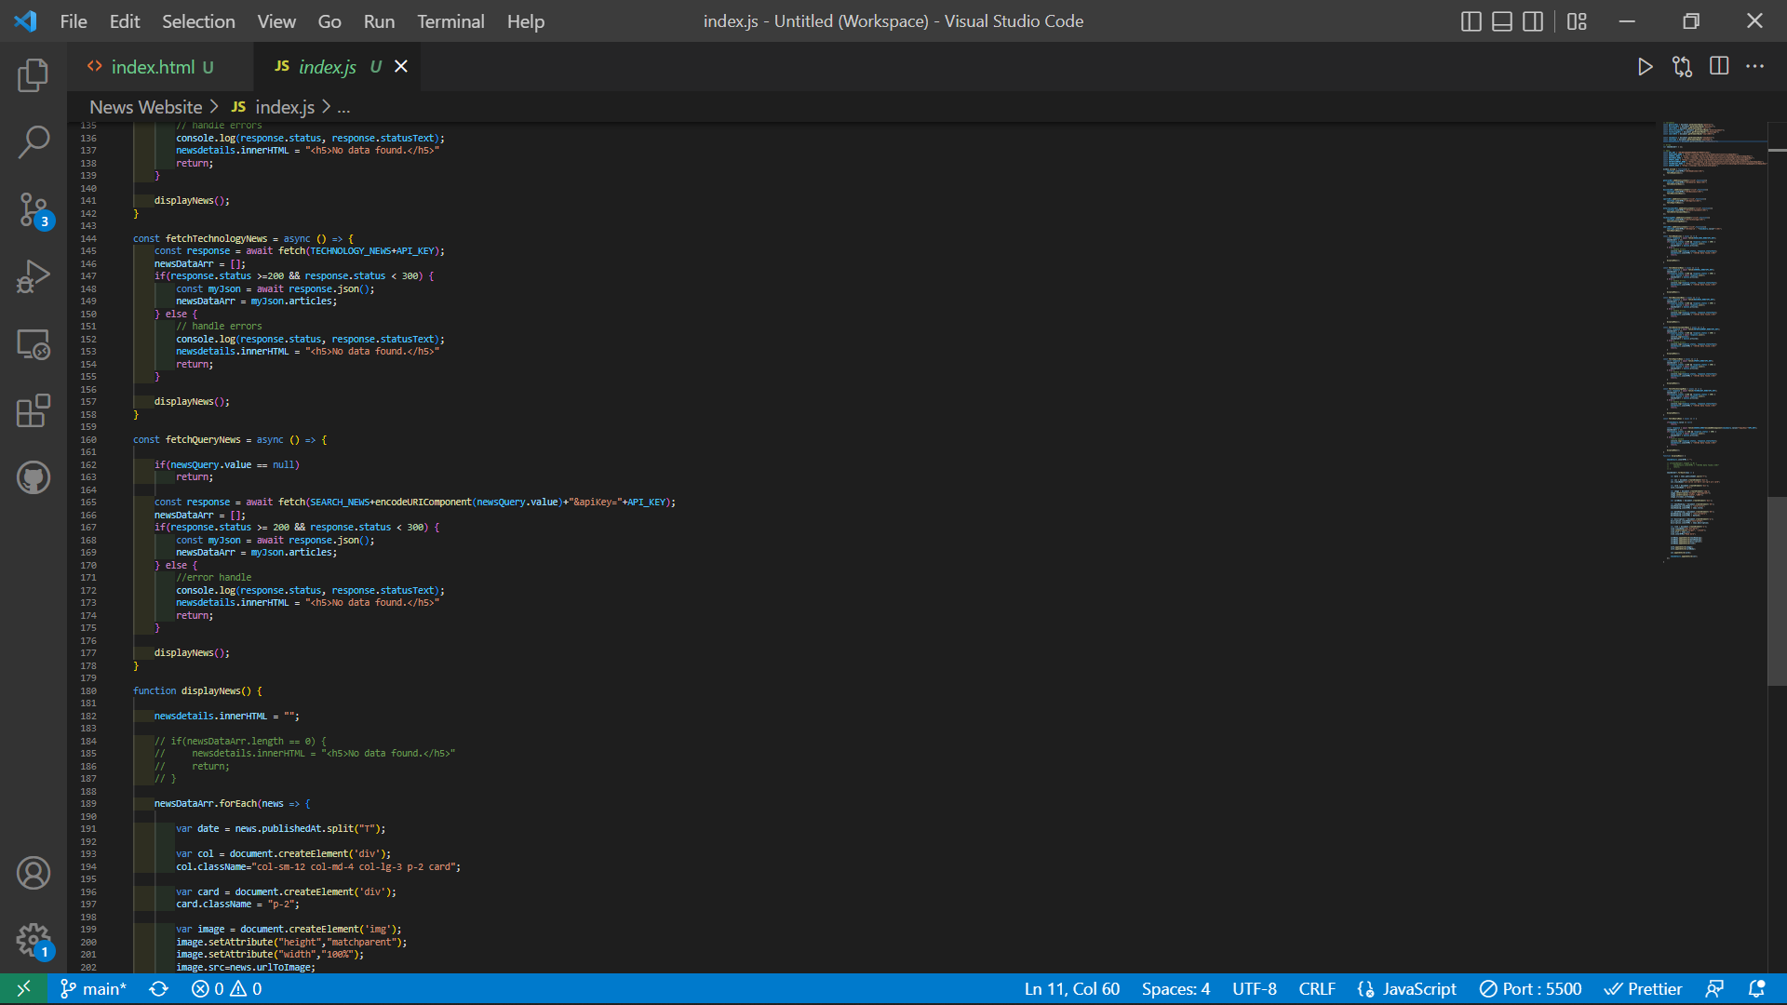

Output-Implementation:

Screenshots:



**Result:** Thus, the details of architectural design/framework/implementation along with the screenshots were provided.